REGISTRATION FORM

Name:

Address:

Phone:
E-mail:
Congregation:

SIGN ME UP FOR:

Fri. Apr. 28 – Sat. Apr. 29 $20.00 ____
(includes all meal functions)

OR
Fri. April 28 ONLY $10.00 ____
(Reception & Dinner)

OR
Sat. April 29 ONLY $10.00 ____
(Continental Breakfast & Lunch)

Please send this form and your check by April 21, 2023 to:

Heather Sessing
16005 Stoneview Dr.
Oklahoma City, OK 73170
405-830-6352
hsessing@gmail.com

Hotel rooms at the Waterford Hotel, across the street from All Souls’ at 6300 Waterford Blvd, are available at $129 per room.

Scholarships are available.
For scholarships, carpool, or other questions, please call Sherry Sullivan at 405-314-2083 or email at sheryl@sssullivanlaw.com

This event is sponsored by
the Episcopal Church Women
of the Diocese of Oklahoma.

We welcome all women in the Diocese to gather for a weekend of renewal, refreshment, and fellowship.

Please join us for the 85th Annual Conference and Bishop’s Day
of the Women of the Episcopal Diocese of Oklahoma
April 28 – 29, 2023
at
All Souls’ Episcopal Church
6400 N. Pennsylvania Ave.
Oklahoma City, OK 73116

“Stay Awake –
Keep Watch”
Bishop Poulson Reed will join us Friday evening for dinner and conversation.
Canon Betsy Randall, our new Diocesan Canon to the Ordinary, will be our Keynote Speaker.
Exhibits will include Cathedral Books & Gifts and other bookstores and ministries around the diocese.

Friday, April 29, 2023
4:00 pm Registration
5:00 pm Pre-dinner reception
6:00 pm Dinner & Conversation
with Bishop Poulson.

Saturday, April 30, 2023
8:00 a.m. Coffee, etc.,
9:00 a.m. Business meeting
10:30 a.m. Keynote Address by
Canon Betsy Randall
12:00 p.m. Lunch with Diamond
Jubilee recognitions
1:30 p.m. Women’s Ministry Grant
Presentations
3:00 p.m. Eucharist

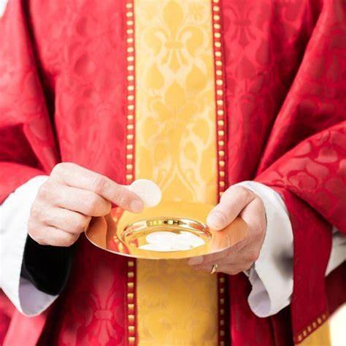

DIAMOND JUBILEE AWARDS
Each year the Diocesan ECW honors women in our midst who have celebrated at least 75 years as a baptized Christian or Confirmand of the Episcopal Church.
Please submit the names of any nominees to Bebe Dotter, 8837 NW 119th St., Oklahoma City, OK 73162 or bbdotter@yahoo.com by April 18, 2023. The following information is needed for each woman to be recognized:
1. Full name:
2. Date of Baptism or Confirmation
3. Place of Baptism or Confirmation
4. Church and/or location of Baptism or Confirmation
5. Place of current church membership
6. Whether the honoree will be attending.

EXHIBITOR’S REGISTRATION
We have limited exhibit space to offer churches, bookstores, and related ministries. We hope your schedule allows you to accept this invitation to join us. If so, please furnish the name of your Church or Ministry and the contact person and contact information by April 21st to Susan Robertson, srobertson7751@gmail.com (405-834-7013).

WOMEN’S MINISTRY GRANTS
We are again offering two $500 and two $1,000 grants for women’s ministries in the diocese. Please contact Deacon Linda Paul, deaconlbpaul@gmail.com (918-629-7259) for applications and information. Application deadline April 21, 2023

NECROLOGY REPORT
As we remember our sisters who have died in the recent past, please send us the names of women in your church who have died since May 1, 2022 whom you would ask that we offer up in prayer during our Saturday morning Eucharist. Please send their names and names of their congregations to Bebe Dotter, 8837 NW 119th St., Oklahoma City, OK 73162 or bbdotter@yahoo.com by April 18, 2023.

